An Evening with Tom Crisp 10th September 2018

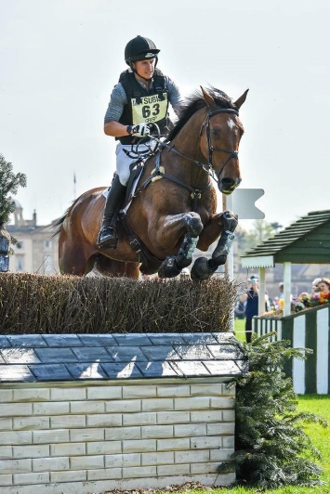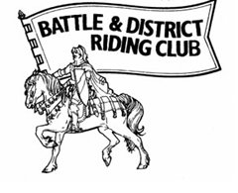

Hosted with Battle and District Riding Club

Supported by Baileys Horse Feed and High Weald Horse Hydro

To include demos, a panel of experts including Juliette Lilly (saddler), Evonne Armstrong (hydro), Helen Gordon (Baileys) and a raffle sold on the evening in aid of the Kent, Surrey and Sussex Air Ambulance

£10 pp to start at 6:30pm Limited spaces available  
Knowle, Newick Lane, Mayfield, TN20 6RD

To book please email [catherinesheppard@gmail.com](mailto:catherinesheppard@gmail.com)  
Payment secures your place

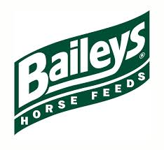

If you would like to donate a prize for the raffle please let us know